1. **Proporciona una SQL que muestre los siguientes datos:**
   * Nombre Actor
   * Apellido Actor

|  |
| --- |
| SELECT first_name, last_name FROM actor |
| SELECT COUNT (*) FROM (SELECT first_name, last_name FROM actor) AS M; |

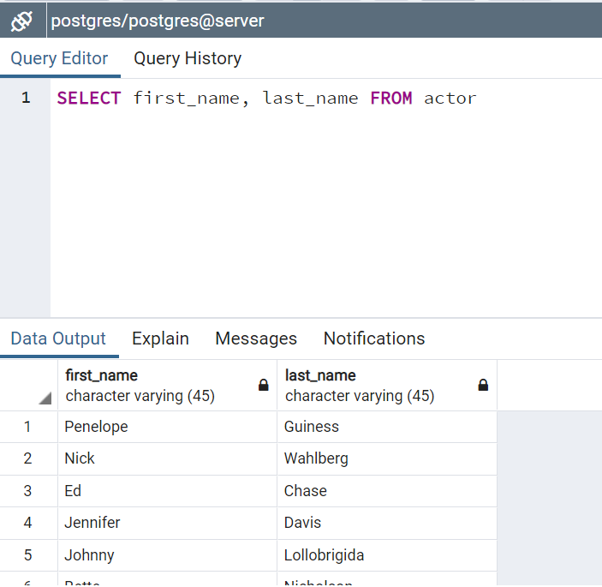

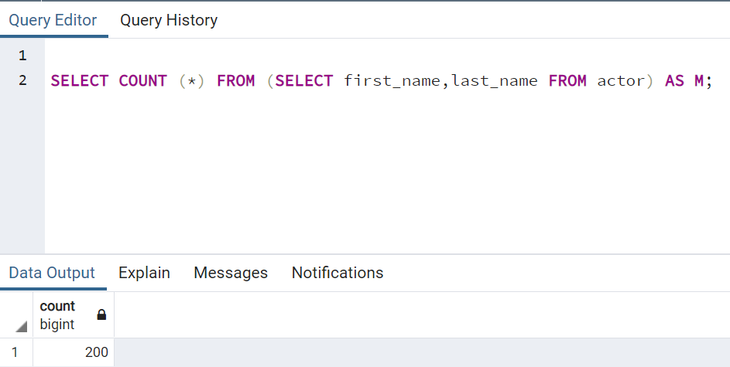

**2.Proporciona una SQL que muestre los siguientes datos:**

* + Nombre y apellido Actor,
  + Título de la Película

|  |
| --- |
| SELECT actor.first_name, actor.last_name, film.title  FROM actor  JOIN film_actor  ON actor.actor_id=film_actor.actor_id  JOIN film  ON film_actor.film_id=film.film_id |
| SELECT COUNT (*) FROM (SELECT actor.first_name, actor.last_name, film.title  FROM actor  JOIN film_actor  ON actor.actor_id=film_actor.actor_id  JOIN film  ON film_actor.film_id=film.film_id) AS A |

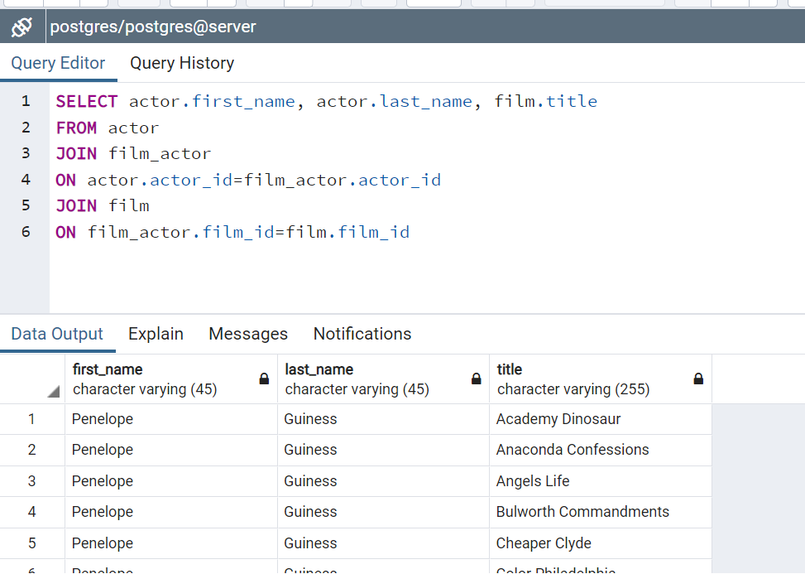

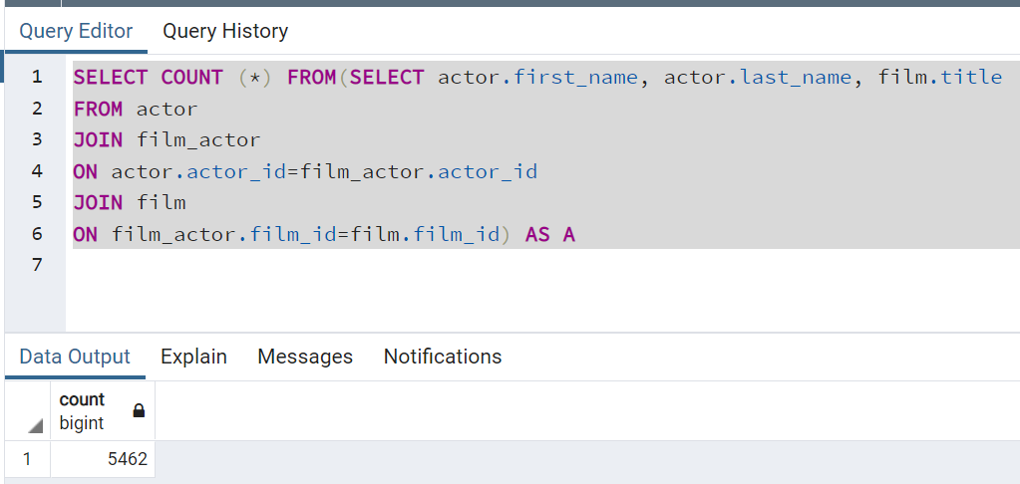

**3.Proporciona una SQL que muestre los siguientes datos:**

* + Nombre y apellido Actor
  + Número de películas
  + Ordenar de mayor a menor

|  |
| --- |
| SELECT actor.first_name, actor.last_name, COUNT(film.title) AS nveces  FROM actor  JOIN film_actor  ON actor.actor_id=film_actor.actor_id  JOIN film  ON film_actor.film_id=film.film_id  GROUP BY actor.first_name, actor.last_name  ORDER BY nveces desc |
| SELECT COUNT(*) FROM  (SELECT actor.first_name, actor.last_name, COUNT(film.title) AS nveces  FROM actor  JOIN film_actor  ON actor.actor_id=film_actor.actor_id  JOIN film  ON film_actor.film_id=film.film_id  GROUP BY actor.first_name, actor.last_name  ORDER BY nveces desc) as c |

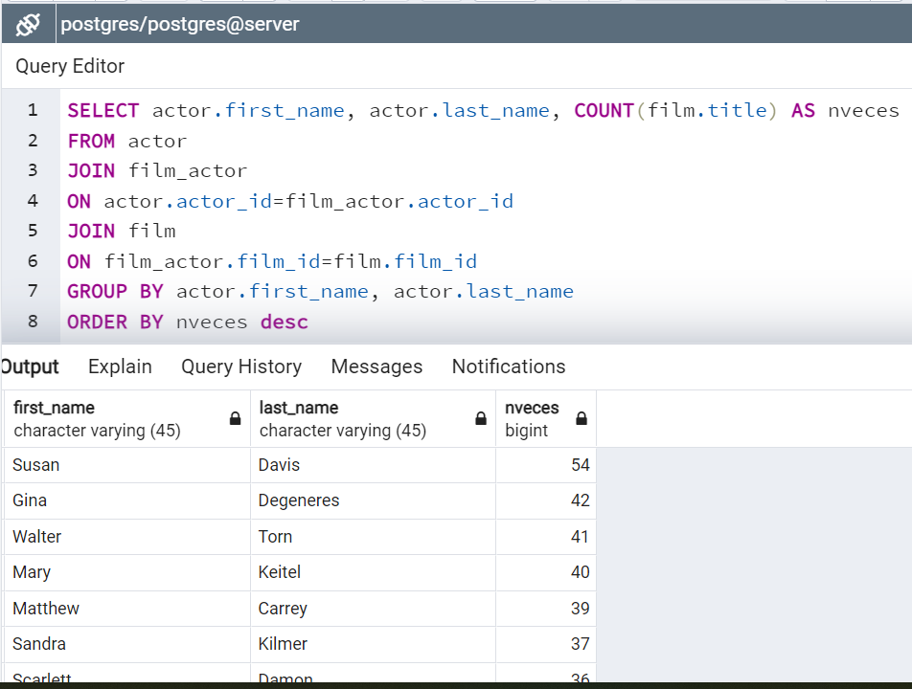

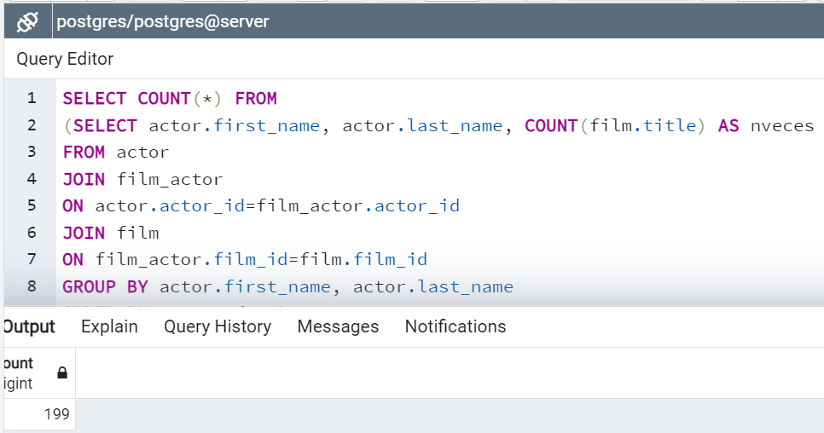

**4.Proporciona una SQL que muestre los siguientes datos:**

* + Película
  + Número de veces alquilada (orden de mayor a menor)

|  |
| --- |
| SELECT film.title, COUNT(rental.rental_id) AS nveces  FROM film  JOIN inventory  ON film.film_id = inventory.film_id  JOIN rental  ON inventory.inventory_id = rental.inventory_id  GROUP BY film.title  ORDER BY nveces desc |
| SELECT COUNT (*) FROM  (SELECT film.title, COUNT(rental.rental_id) AS nveces  FROM film  JOIN inventory  ON film.film_id = inventory.film_id  JOIN rental  ON inventory.inventory_id = rental.inventory_id  GROUP BY film.title  ORDER BY nveces desc) as c |

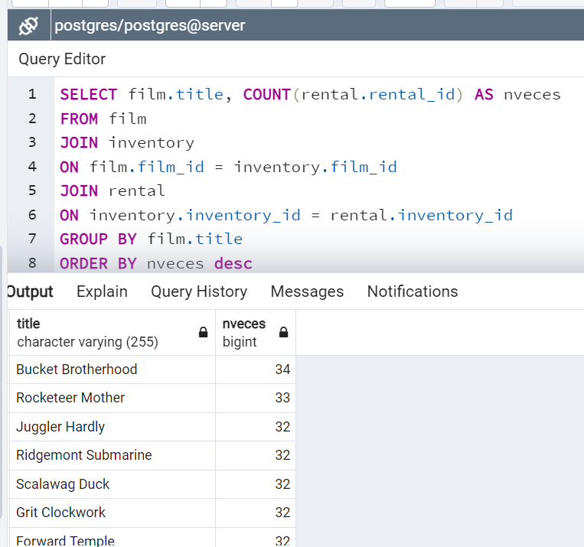

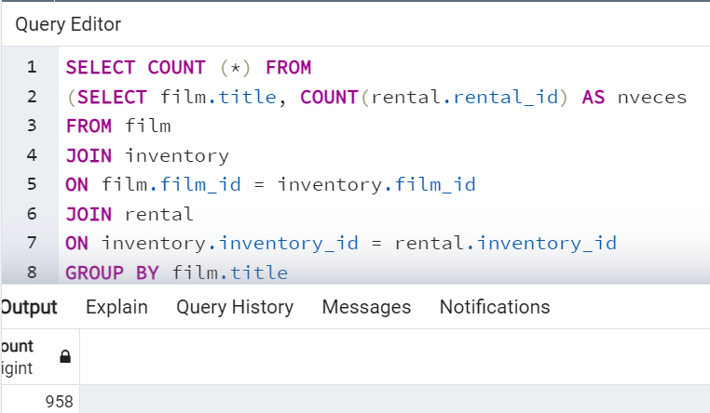

**5.Proporciona una SQL que muestre los siguientes datos:**

* + Película
  + Dinero recaudado por película(ordenado)

|  |
| --- |
| SELECT film.title, SUM(payment.amount) AS recaudacion  FROM film  JOIN inventory  ON film.film_id=inventory.film_id  JOIN rental  ON inventory.inventory_id=rental.inventory_id  JOIN payment  ON rental.rental_id=payment.rental_id  GROUP BY title  ORDER BY recaudacion desc |
| SELECT COUNT (*) FROM  (SELECT film.title, SUM(payment.amount) AS recaudacion  FROM film  JOIN inventory  ON film.film_id=inventory.film_id  JOIN rental  ON inventory.inventory_id=rental.inventory_id  JOIN payment  ON rental.rental_id=payment.rental_id  GROUP BY title  ORDER BY recaudacion desc) as c |

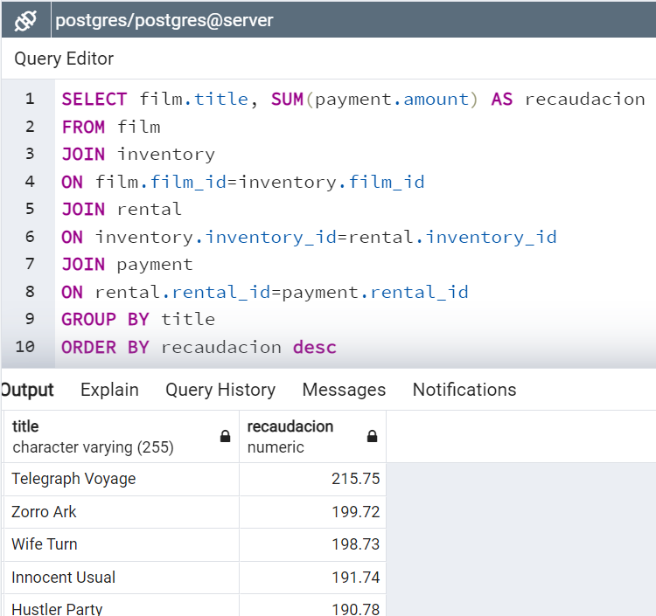

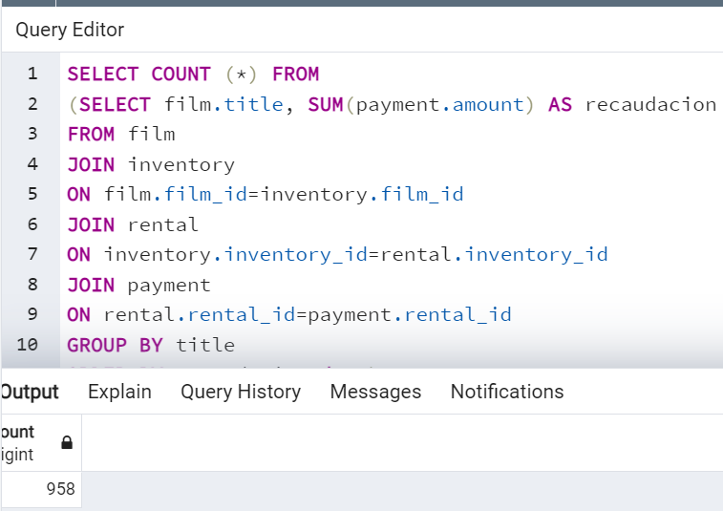

**6.Proporciona una SQL que muestre los siguientes datos:**

* + Nombre y apellido del mejor cliente (mayor gasto)

|  |
| --- |
| SELECT * FROM ( SELECT *,  ROW_NUMBER() OVER (ORDER BY amount DESC) orden  FROM(  SELECT c.first_name, c.last_name, sum(p.amount) amount  FROM public.customer c  JOIN public.payment p  ON c.customer_id=p.customer_id  GROUP BY c.first_name, c.last_name) ini)base  WHERE orden=1 |
| SELECT COUNT(*) FROM(  SELECT * FROM( SELECT *,  ROW_NUMBER() OVER (ORDER BY amount DESC) orden  FROM(  SELECT c.first_name, c.last_name, sum(p.amount) amount  FROM public.customer c  JOIN public.payment p  ON c.customer_id=p.customer_id  GROUP BY c.first_name, c.last_name) ini)base  WHERE orden=1)AS CC |

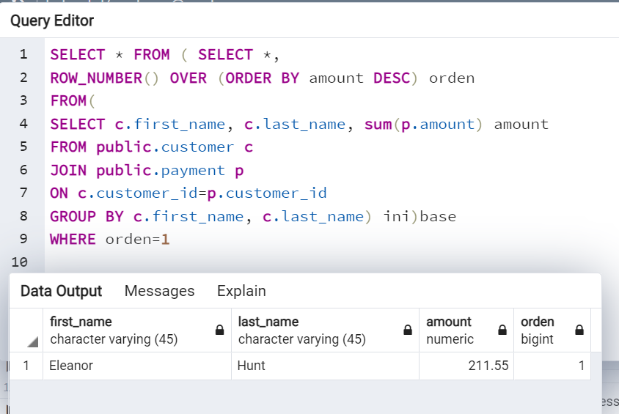

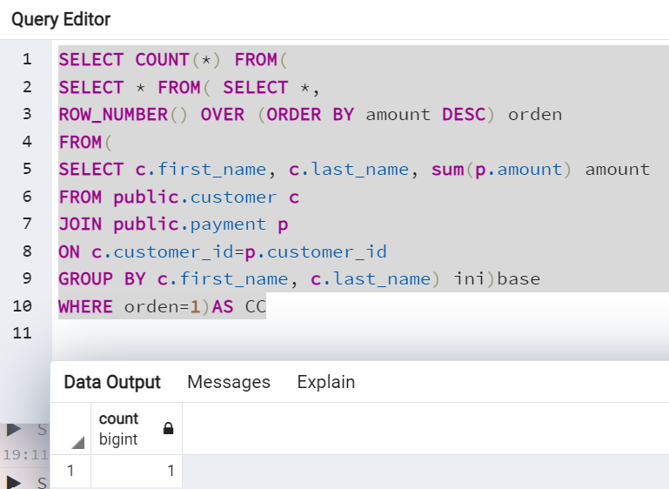

**7.Proporciona una SQL que muestre los siguientes datos:**

Nombre y apellido del mejor cliente (mayor numero alquileres)

|  |
| --- |
| SELECT * FROM( SELECT *,  ROW_NUMBER() OVER (ORDER BY rental DESC) orden  FROM(  SELECT customer.first_name, customer.last_name, COUNT(rental.rental_id) rental  FROM customer  JOIN rental  ON customer.customer_id=rental.customer_id  GROUP BY customer.first_name, customer.last_name) ini)base  WHERE orden=1 |
| SELECT COUNT(*) FROM(  SELECT * FROM( SELECT *,  ROW_NUMBER() OVER (ORDER BY rental DESC) orden  FROM(  SELECT customer.first_name, customer.last_name, COUNT(rental.rental_id) rental  FROM customer  JOIN rental  ON customer.customer_id=rental.customer_id  GROUP BY customer.first_name, customer.last_name) ini)base  WHERE orden=1)AS CC |

